LOOPS IN PYTHON

**Loops in Python – For, While and Nested Loops**

Python programming language provides two types of Python loops checking time. In this article, we will look at Python loops and understand their working with the help of example – **For loop** and **While loop** to handle looping requirements. Loops in Python provides three ways for executing the loops.

**While Loop in Python**

In [Python](https://www.geeksforgeeks.org/python-programming-language/), a [while loop](https://www.geeksforgeeks.org/python-while-loop/) is used to execute a block of statements repeatedly until a given condition is satisfied. When the condition becomes false, the line immediately after the loop in the program is executed.

**Python While Loop Syntax:**

while expression:  
 statement(s)

**Example of Python While Loop**

Let’s see a simple example of a while loop in Python. The given Python code uses a **‘while'** loop to print **“CodroidHub”**three times by incrementing a variable called **‘count'** from 1 to 3.

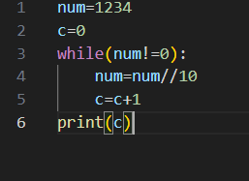

**Output:**

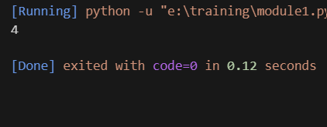

**Using else statement with While Loop in Python**

The else clause is only executed when your while condition becomes false. If you break out of the loop, or if an exception is raised, it won’t be executed.

**Examples of While Loop with else statement:**

Here is an example of while loop with else statement in Python:

The code prints “CodroidHub” three times using a ‘while' loop and then, after the loop, it prints “In Else Block” because there is an “else” block associated with the ‘while' loop

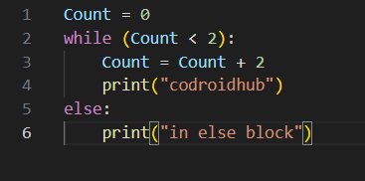

**Output:**

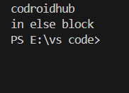

**For Loop in Python**

[For loops](https://www.geeksforgeeks.org/python-for-loops/) are used for sequential traversal. For example: traversing a [list](https://www.geeksforgeeks.org/python-lists/)or [string](https://www.geeksforgeeks.org/python-string/) or [array](https://www.geeksforgeeks.org/python-arrays/)etc. In Python, there is “for in” loop which is similar to [foreach](https://www.geeksforgeeks.org/g-fact-40-foreach-in-c-and-java/) loop in other languages. Let us learn how to use for loops in Python for sequential traversals with examples.

**Example:**

The code uses a Python for loop that iterates over the values from 0 to 3 (not including 4), as specified by the **range(0, n)**construct. It will print the values of **‘i'** in each iteration of the loop.

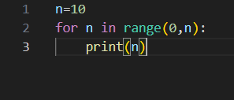

**Output:**

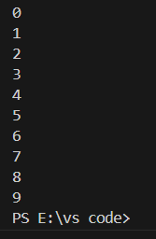

**Nested Loops in Python**

Python programming language allows to use one loop inside another loop which is called [nested loop](https://www.geeksforgeeks.org/python-nested-loops/). Following section shows few examples to illustrate the concept.

**Nested Loops Syntax:**

for iterator_var in sequence:  
 for iterator_var in sequence:  
 statements(s)  
 statements(s)

**Example:** This Python code uses nested **‘for'** loops to create a triangular pattern of numbers. It iterates from 1 to 4

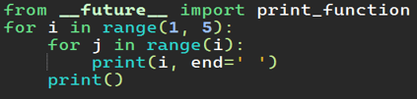

**Output:**

